# Login Testing

Log1.

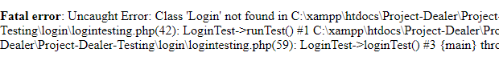

The above error occurred as we did not have a login class for login functionality. So, we had to refactor.

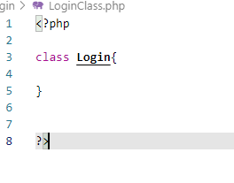

Login class was created. Let’s test again.

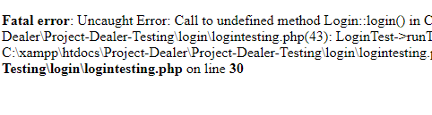

Again, an error with login method was seen, so we had to refactor and create a method login.

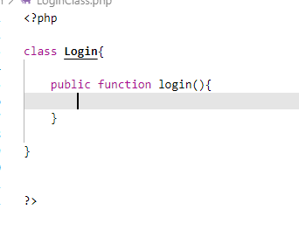

After creating an empty login method, we ran the test again to see following results:

Since we had two testcases for login, invalid and valid login test, we get two test results:

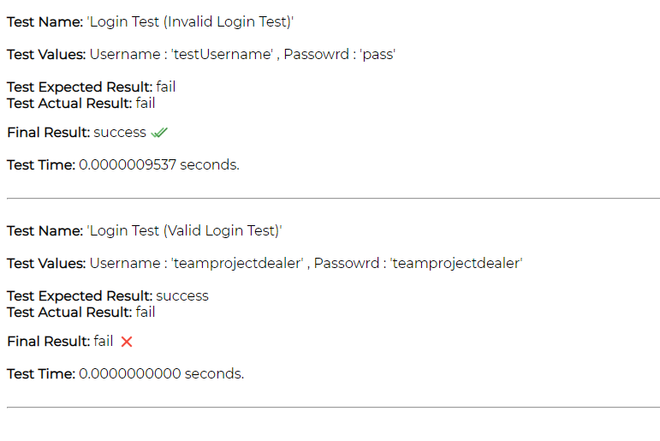

Since the login method has no code at all, whatever details are provided for login will fail on test actual as seen on first and second test results.

Now, the main code for logging in was written in the login method.

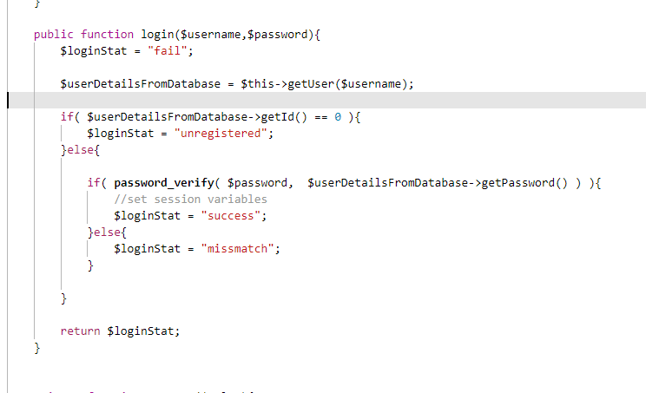

Now on running the test, following results were shown:

